## SOFTWARE TEST LIFE CYCLE (STLC)

* STLC is a procedure to test the software.
* STLC is a part of SDLC
* Defect life cycle is a part of STLC

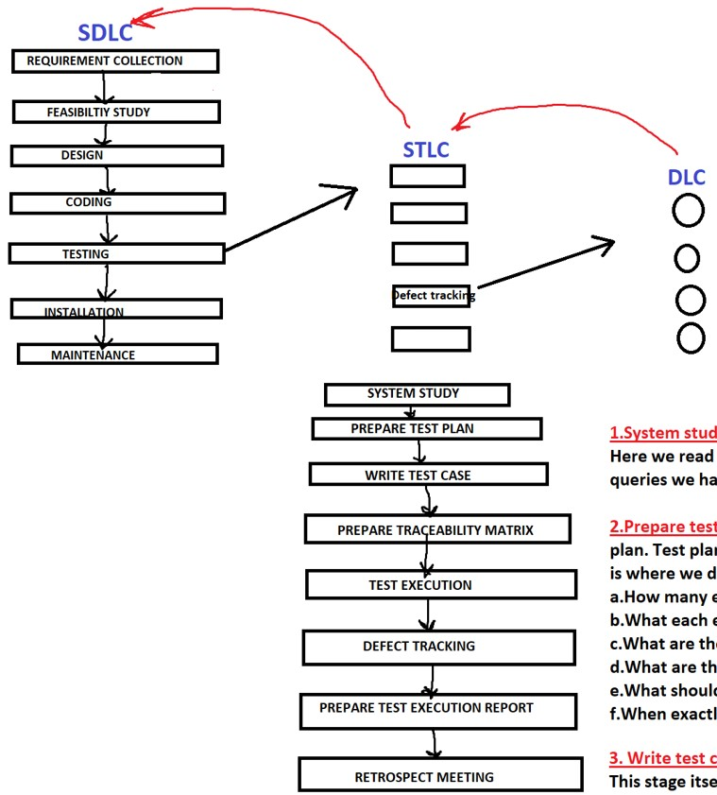

* + - * 1. **System Study:**

Read the requirement, understand the requirement if you have any queries, interact with BA, developers or customer.

* + - * 1. **Prepare Test plan:**

Once after reading and understanding the requirement, we go for preparing the test plan.

Test plan is a document which drives all the future testing activities:

* + 1. Here we decide how many engineers we require to complete the testing.
    2. What is the total time for completing the testing/project.
    3. What each engineer should do in different stages of testing.
    4. What are types of testing we will conduct in future.
    5. What are the features that are to be tested and not to be tested
    6. What is the testing approach
    7. When each activity should start & end.

**3.** **Write test cases:**

Test case is a document which contains all possible scenarios. This stage itself has got different activities like:

* 1. Identify all possible scenarios
  2. Write test case
  3. Review test case
  4. Fix the review comments
  5. Verify the fix
  6. Test case approval
  7. Store the test case in test case repository
     1. **Prepare traceability matrix:**

Once after we write test case, the biggest question is what is the proof that each and every requirement has got a test case?

We prepare traceability matrix to ensure that each and every requirement has got at least one test case.

**Traceability Matrix/ Requirement Traceability Matrix (RTM)/ Cross**

**Reference Matrix (CRM)** What is Traceability Matrix?

It is the document which we prepare to make sure that every requirement has at least one test case.

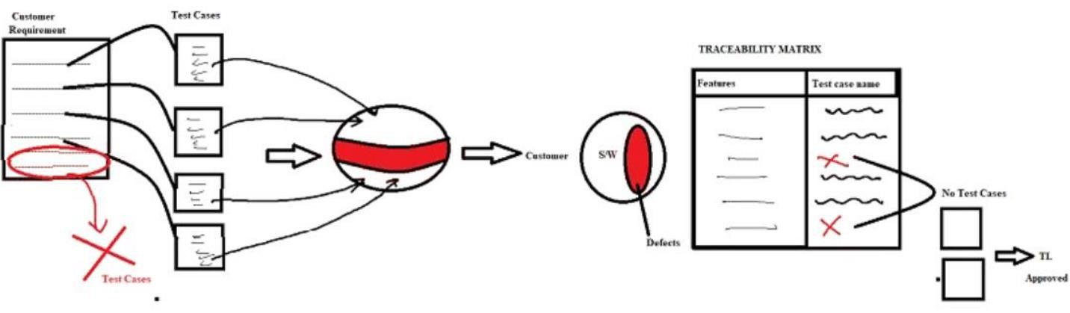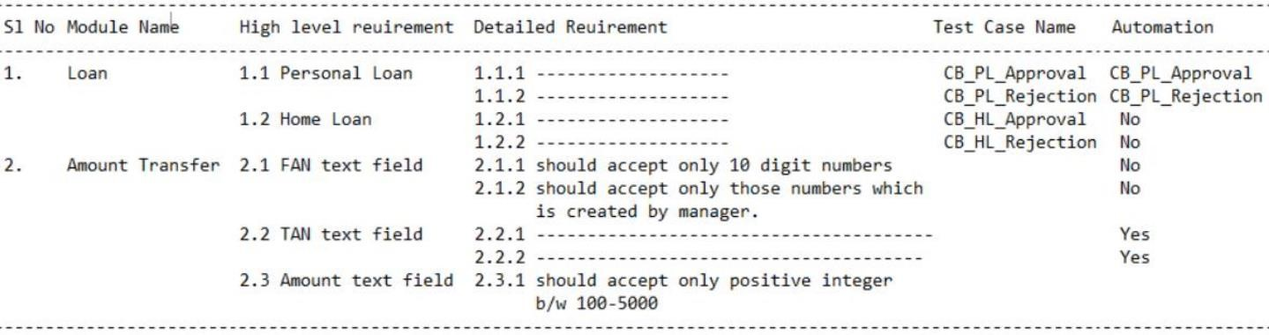

***Advantages*:**

1. It ensures that every requirement has got at least one test case, which indirectly assures you that you are testing every feature at least once
2. It gives traceability from high level requirement till automation script name

***Drawback***

1. It will not ensure that you that got 100% coverage

**Types of Traceability Matrix:**

There are 3 types of traceability Matrix.

1. ***Forward Traceability Matrix:*** Mapping from the root document to derived document is called forward traceability matrix.

Ex: Mapping from Req to test case and test case to automation script

1. ***Backward Traceability Matrix:*** Mapping from derived document to root document is called as Backward Traceability Matrix.

Ex: Mapping from test scripts to test cases and test cases to requirement.

1. ***Bi-Directional traceability Matrix:*** Doing both forward and backward traceability matrix is called as Bi-directional traceability Matrix

**Interview Questions:**

* 1. ***Difference between Traceability Matrix and Test case review:***

|  |  |
| --- | --- |
| *Traceability Matrix* | *Test case review* |
| Here we check every req has got at least one test case. | Here we check test case is covering all possible scenarios for specific requirement. |
| Here we don’t check whether test case is covering all possible scenarios for a specific requirement. | Here we don’t check whether every requirement has got at least one test case. |

* 1. ***If there is no requirement then how will you prepare traceability matrix?***

I will explore the application and understand it, identify the scenarios, document it, write test cases. Once after writing the test cases what is the guarantee that you have written all the test case for all the features, to ensure that we write traceability matrix Here we list all the features that are there in the product and map it to test case.

*Features Test case name*

Login ---------------------------

Signup ---------------------------

Forgot password No

***Q.3 Assume that last day when you are about to release the product to the customer, if there is a critical / blocker defect what will you do? Will you release product to the customer or not?***

As a TE I’m not a decision maker so I will list all the defects which are pending and the impact of the defect on the business also I suggest whether to release or not and send it to PM. It is the manager who should take a calculated decision and decide

* + 1. **Test Execution:** This is the stage wherein we test the product for 4-8 cycles (if it is agile) and 30-60 cycles (if it is traditional model).
* This is the stage where we execute all the test cases.
* This is where we conduct all types of testing
* This is where we catch the bugs and help the developers to improve the quality of the product. This is where TE are productive to the organization
* This is the stage where the T.E spends a lot of time
* This is the stage where test engineers become productive to the organization

* + - 1. **Defect tracking:**

Once after test execution, obviously we are going to find the defects. Each defect that we find should be tracked in an organized way. This is called as Defect tracking.

* + - 1. **Test execution report:**

At the end of every test cycle we prepare test execution report. It is a document which we prepare and provide to the customer at the end of every test cycle.

This report covers:

* + - * Total no. of test cases
      * Total no. of test cases executed.
      * Total no. of test cases not executed. • No of test cases passed. • No of test cases failed • What is the pass percentage?
      * What is the fail percentage?

We will prepare this document and send it to the customer. From customer’s POV this is the end of the project. But from company’s POV we have one more activity called as Retrospective meeting.

**8.** **Retrospective meeting/Project closure meeting/Post-mortem meeting:**

Here the entire team will sit together and discuss about the list of achievements and mistakes, they document all this, that document is called as Retrospect document. In the next release/sprint they open this document in the planning stage and plan in such a way that all the achievements are adopted and all the mistakes are avoided.